Wire Framing Recipe Website

1. Index:
   1. 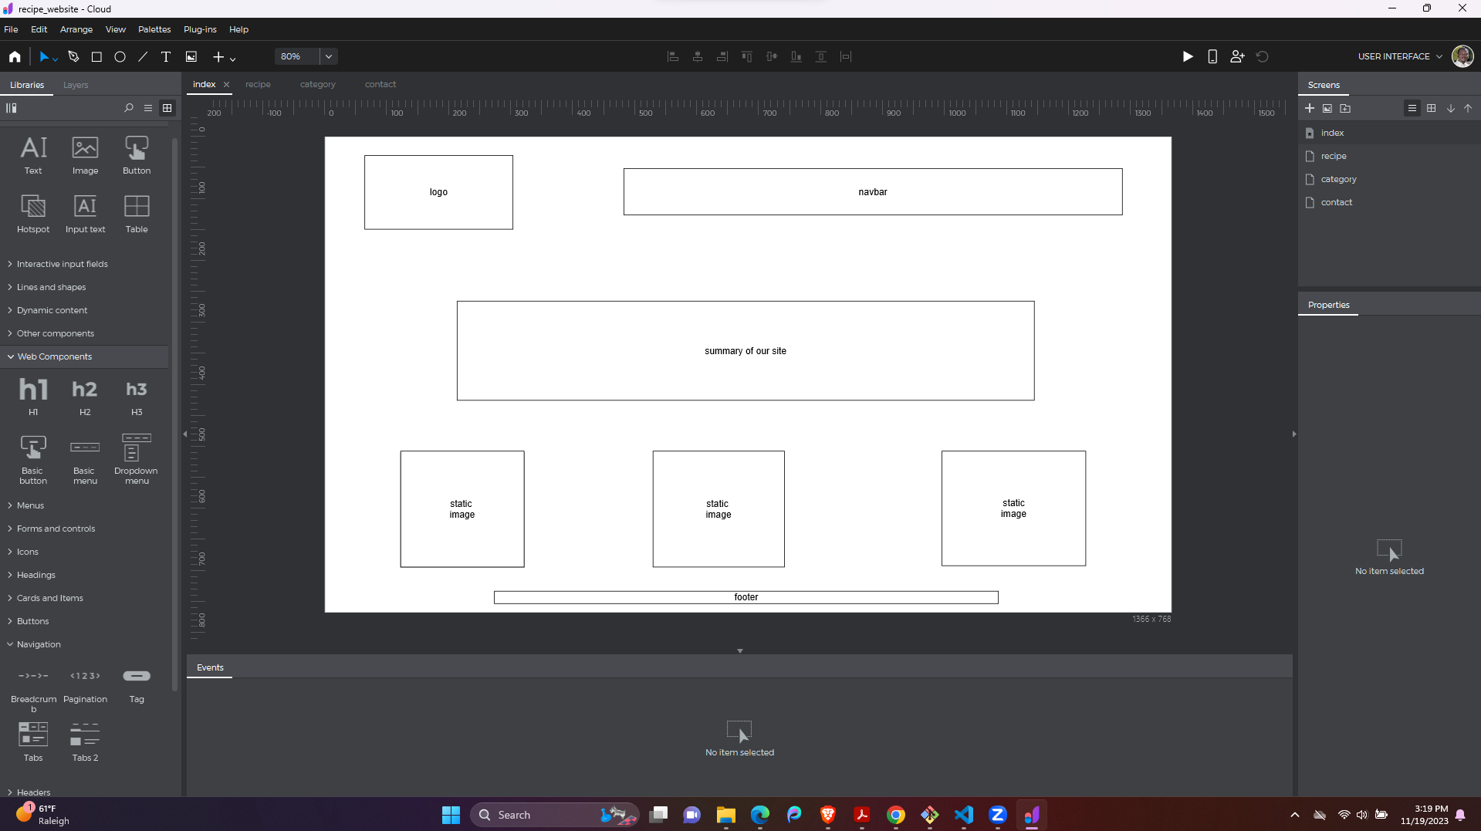
2. Recipe page:
   1. 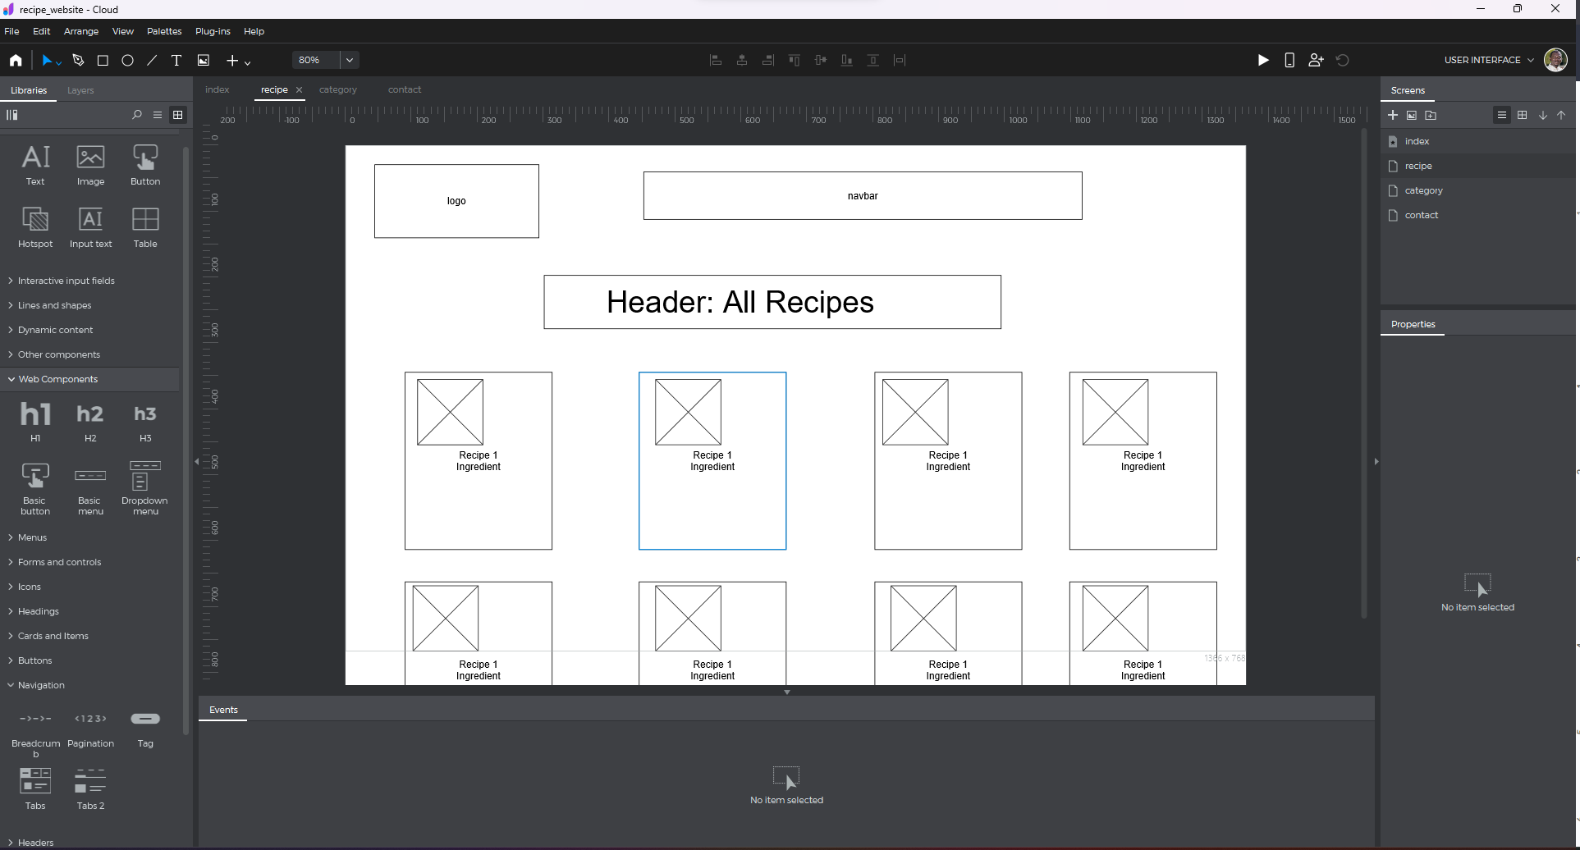
3. Category:
   1. 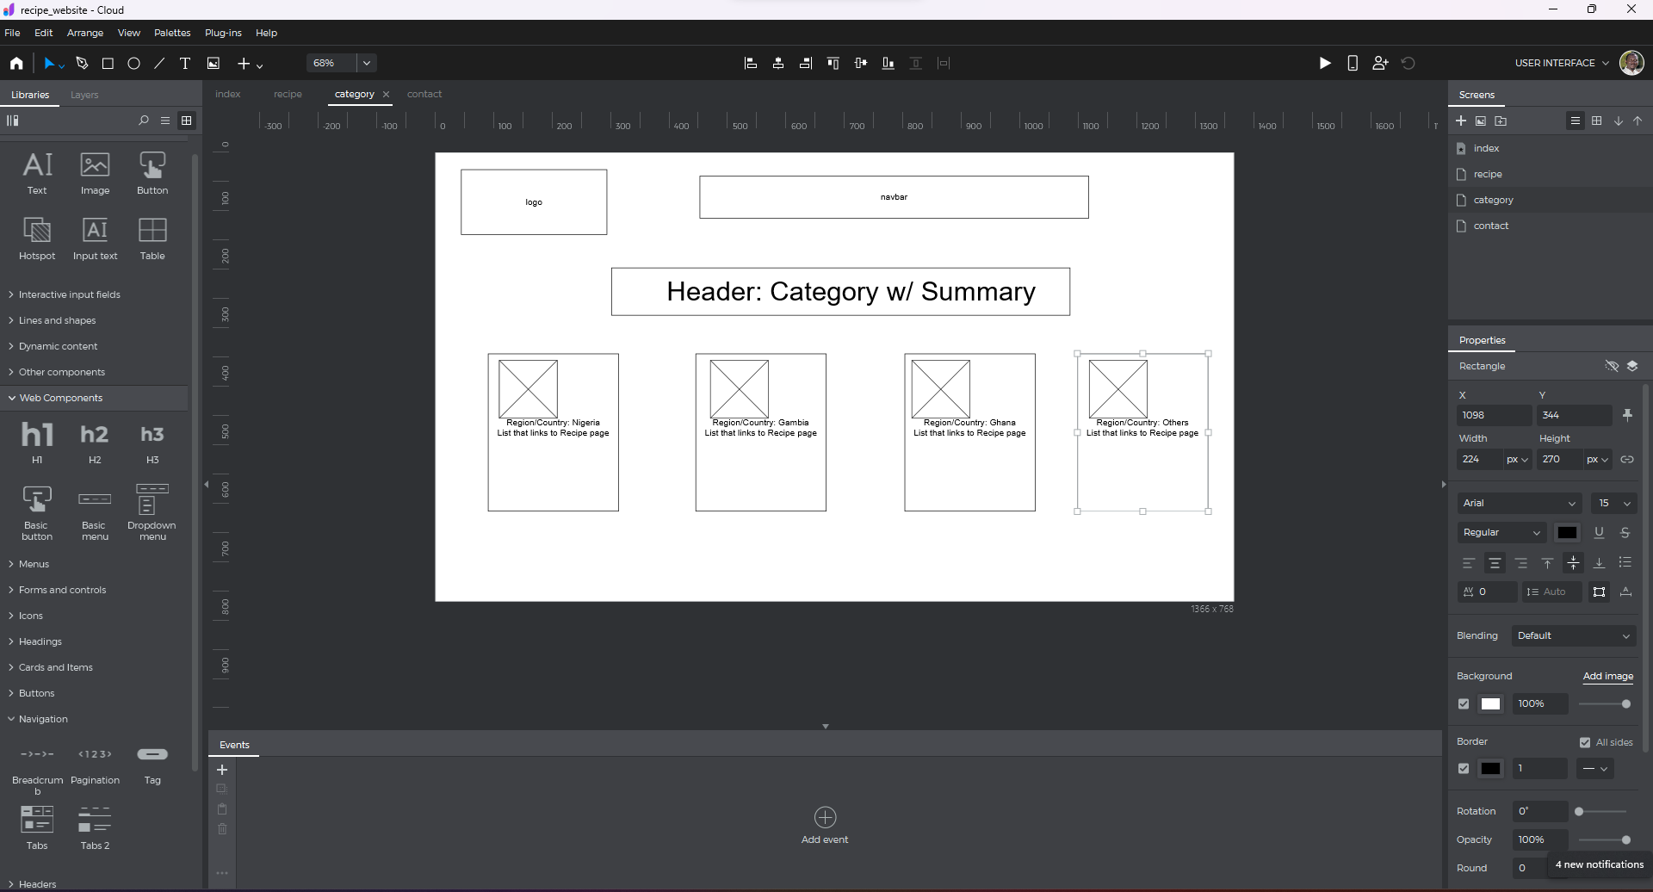
4. Contact:
   1. 